
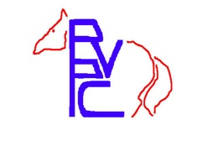
Roanoke Valley Pony Club
2026 Fun Frolic Series Prize List

Combined Tests, Dressage, and Working Equitation Show
Green Hill Park Equestrian Center, Salem, VA

Spring Frolic – April 12, 2026 (closing date Apr 8)
Fall Frolic - September 20, 2026 (closing date Sep 16)

Show Secretary: Karen Childers, 4178 Dry Valley Rd, Radford VA 24141
roanokevalleyponyclub@gmail.com, 540-230-8224

Judge: Spring: Beckie Mitchell, L
Fall: TBD

Levels Offered:
Dressage Tests: 2023 USDF/USEF Intro – Second Level. Higher level dressage tests available with permission from the manager.
2026 USEA/USEF Eventing tests Starter – Preliminary
USEF/WDAA 2021 Western Dressage Tests Intro – Level 3
2025 Working Equitation tests – Levels 1 - 7
Combined Tests: Tadpoles – Preliminary

Specifications:
Tadpoles 2023 USDF Intro Test A; Poles on the ground. Coach is allowed in ring for both phases.
Cross Rails: 2023 USDF Intro Test B; Jumps 18” max. Coach is allowed in ring for SJ.
Green: 2023 USDF Intro Test C; Jumps 2’ max (no oxers or combinations)
Adv Green: 2026 USEF Beginner Novice Test A; Jumps 2’3” max
Beg. Novice: 2026 USEF Beginner Novice Test B; Jumps 2’7” max
Novice: 2026 USEF Novice Test A; Jumps 2’11” max
Training: 2026 USEF Training Test A; Jumps 3’3” max
Leadline: Walk, optional Trot (FREE!! rail class, ribbons/prizes for all)

Fees:
Dressage Tests $30 per test
Combined Tests $50 per test
Schooling Jumper Round $20 per round
Leadline FREE!!
Stabling $20 per stall
Office Fee $5 per horse/rider combination
USPC Discount -$5 per horse/rider combination for current USPC members

Division Information:

Special rules for Tadpole and X-Rails Divisions! Tadpole: Coaching allowed - Coach may be in the ring with the rider for both jumping and dressage phases, and may provide any assistance needed. X-Rails: Coaching allowed in jumping phase - Coach may be in the ring with the rider for jumping phase, and may provide any assistance needed. Dressage test may be read without penalty.

Schooling rounds - If you are competing in a CT, then schooling rounds may only be done after your competition round. Schooling rounds may also be added on show day, just come to the show office to pay for additional rounds.

Directions to GHPEC:
The physical address of GHPEC is 2961 Harborwood Road, Salem, VA, 24153
Directions can be found at www.GHPEC.org.

Other information: (PLEASE READ!!)
Entries are not complete without payment! Late entries MAY be accepted and a $10 late fee charged, at the Show Secretary’s discretion. Ride times will be emailed to competitors on the Thursday before the show, and will be posted on www.RoanokeValleyPonyClub.org. Scratches prior to closing date will receive a full refund less a $10 office fee. After closing date, NO refunds will be given. All dogs MUST be leashed. Dress is casual, but neat and tidy. Half chaps are allowed. ASTM-approved helmets must be worn whenever mounted; Body protective vests are required for cross country schooling; medical armbands or medical ID bracelets must be worn when jumping.

Ribbons to 6th place for each division. Show management reserves the right to combine, divide, or cancel classes as entries warrant.

Concessions by Blue Ridge Equine Society will be available on show grounds.

You are welcome to bring non-competing horses for a $20 grounds fee, and proof of negative Coggins.

Attention XC Schoolers: If you wish to school XC, you must pay a fee of $10. For safety, please go with at least one other person or bring a ground person, and check in with the secretary before going on course and after you return.

* Make checks payable to RVPC and mail with completed entry and signed release (page 4) and current (within 12 months of show date) negative Coggins to show secretary at address listed above. Or use electronic entry form and pay via PayPal. Entries, including payment, must be RECEIVED on the closing date or before to be considered on time.

RVPC Fun Frolic Entry Form – 2026
(One horse/rider combo per entry form)

Show Date: |  | Spring (4/12) |  | Fall (9/20)

Horse:
Rider:
Rider’s age as of 1/1/26: |  |  |  | 12 & Under |  |  | 13-17 |  | 18 & Over
Email:
Phone:
USPC Member? | Y / N |  | If yes, indicate club:

 |  |  |  | Fees:
Combined test Level(s): No more than 2 consecutive levels
Dressage Test(s):
Jumper Schooling Round(s):
Level:
Level:
Leadline:
Stabling:
XC Schooling Fee:
Office Fee |  |  |  | $5
USPC Member Discount:
Total Amount Due:

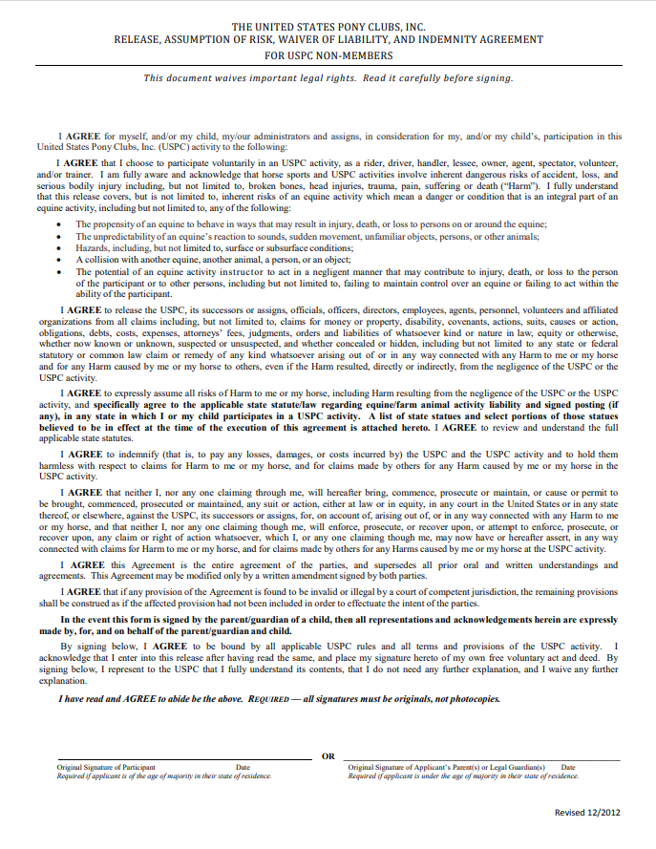
Printed Name:

