Working Equitation clinic at Green Hill Park Equestrian Center (Salem, Va)
May 29 – 30, 2026

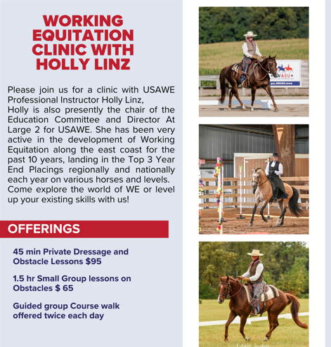

Working Equitation clinic at Green Hill Park Equestrian Center (Salem, Va)
May 29 – 30, 2026

Rider must be a member of Green Hill Park or pay additional $15 day fee to the park
Stabling available $20/day. Riders may ride both days
_______Friday May 29th _____________Saturday May 30th
Stabling request: Thursday: Night Friday: Night Saturday: Day
Name: ____________________________________
Email: _____________________________________
Phone Number: ________________________
Horse’s name:__________________________

Mail clinic entry to Tamla Nichols 1557 Bore Auger Road Blue Ridge, Va 24064
Questions: tamlanichols@verizon.net or 540-871-9891
Make check to Green Hill Park Equestrian Center
Include:
__ Entry Form
__ Clinic Fee, $95/day private, $65/day group
__ Coggins
__ Day Fee if not a park member, $15/day
__ Stabling fee if requested, $20/day

Your spot will be reserved when the entry form, coggins and fees are received.

