March 14 -15, 2026
Working Equitation Ease of Handling Clinic
Green Hill Park Equestrian Center Salem, Va
Clinician Elizabeth Barker
Elizabeth is a triple certified Riding instructor, trainer and equine bodyworker through Meredith Manor International Equestrian Centre. She has been a professional in the equine industry for over 20 years and has experience in a list of different disciplines. Her enthusiasm for the past few years has been Working Equitation. She says it combines her passion for classical training with the excitement of gymkhana-like obstacles to form an ultimate cross training sport.

In 2024 she earned Champion at Eastern Zone Championships, reserve champion in Region 6, 8th place Nationally, and was reserve champion for Working Equitation East, all at L5. The 2025 season she was eastern region's reserve champion at L6 along with earning Champion in Region 6, and 4th place Nationally. In 2026 she'll move forward with competing at the Master's level.

Though her love of the show pen is exciting for her, her love of teaching takes precedence in her business. She teaches her students the fundamentals of balance, following the horse's motion, and correct application of the riding aids in order to communicate with the horse to the best of their abilities. Her approach is quiet and slow so the students can benefit from learning a solid foundation at their own pace.
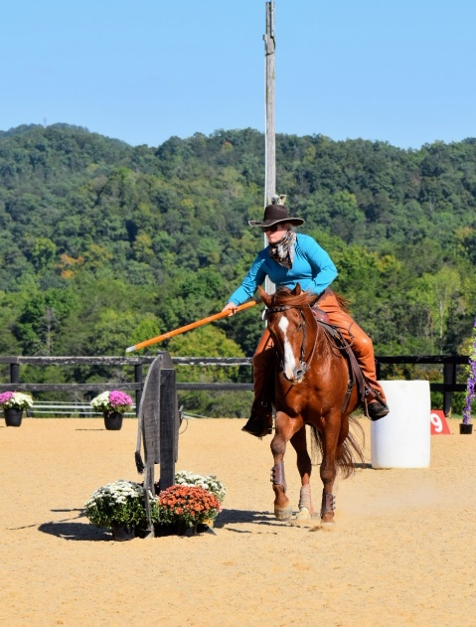

$90 – private 45 minute lesson with obstacles
Rider must be a member of Green Hill Park or pay additional $15 day fee to the park
Stabling available $20/day.

Riders may ride both days if desired
_______Saturday March 14th _____________Sunday March 15th
Stabling request: Friday: Night Saturday: Night Sunday: day
Name: ____________________________________
Email: _____________________________________
Phone Number: ________________________
Horse’s name:__________________________

Mail clinic entry to Tamla Nichols 1557 Bore Auger Road Blue Ridge, Va 24064
Questions: tamlanichols@verizon.net or 540-871-9891
Make check to Green Hill Park Equestrian Center
Include:
__ Entry Form
__ Clinic Fee, $90/day
__ Coggins
__ Day Fee if not a park member, $15/day
__ Stabling fee if requested, $20/day

Your spot will be reserved when the entry form, coggins and fees are received.

Are you familiar with Working Equitation, the rules, and how certain obstacles are to be performed? Yes No
Would you be more comfortable introducing your horse to the obstacles in hand? Yes No

