**July 5 - 6, 2025**

**Working Equitation Ease of Handling Clinic**

**Green Hill Park Equestrian Center Salem, Va**

**Clinician Elizabeth Barker**

Elizabeth is a triple certified Riding instructor, trainer and equine bodyworker through Meredith Manor International Equestrian Centre. She has been a professional in the equine industry for over 20 years and has experience in a list of different disciplines. Her enthusiasm for the past few years has been Working Equitation. She says it combines her passion for classical training with the excitement of gymkhana-like obstacles to form an ultimate cross training sport. Some of her most recent accomplishments are in 2023 she earned Champion for Working Equitation East at L5.

In 2024 she won Champion at Eastern Zone Championships, reserve champion in Region 6, 8th place Nationally, and was reserve champion for Working Equitation East, all at L5. This year she'll be rising into the advance level of L6 and is looking forward to the challenge and a fun season.

Though her love of the show pen is exciting for her, her love of teaching takes precedence in her business. She teaches her students the fundamentals of balance, following the horse's motion, and correct application of the riding aids in order to communicate with the horse to the best of their abilities. Her approach is quiet and slow so the students can benefit from learning a solid foundation at their own pace.

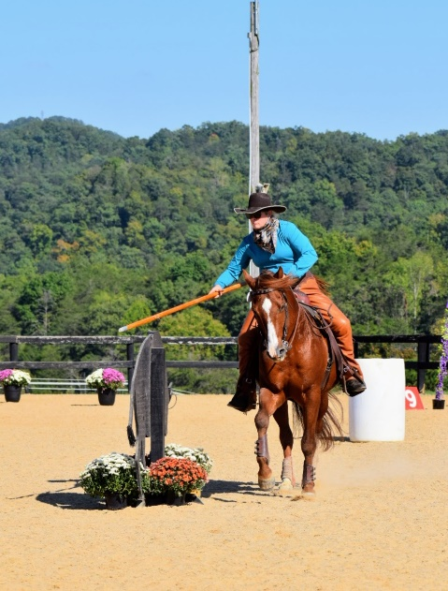

$85 – private 45 minute lesson with obstacles

Rider must be a member of Green Hill Park or pay additional $15 day fee to the park

Stabling available $20/day. Overnight stabling on Saturday can be provided. No overnight stabling on Friday July 4th due to it being a holiday.

Riders may ride both days if desired

_______Saturday July 5th _____________Sunday July 6th

Stabling request: Saturday: day Night Sunday: day

Name: ____________________________________

Email: _____________________________________

Phone Number: ________________________

Horse’s name:__________________________

Mail clinic entry to Tamla Nichols 1557 Bore Auger Road Blue Ridge, Va 24064

Make check to Green Hill Park Equestrian Center

Include:

__ Entry Form

__ Clinic Fee, $85/day

__ Coggins

__ Day Fee if not a park member, $15/day

__ Stabling fee if requested, $20/day